C/o Mashamshire Community Office, 7 Little Market Place, Masham, HG4 4DY
Tel: 01765 680205 Fax: 01765 680209 (Office Hours)
Tel: 01765 650363 (Out of Office Hours) E-mail: mashamparishclerk@gmail.com
Office hours: Monday and Thursday, 13:00 – 17:00
Chairman: Clerk to the Council:
Councillor Flo Grainger Jen Hurford

FLOODING MASHAM AREA
STORMS CIARA AND DENNIS
During the month of February 2020 residents of Masham have received four flood warnings in respect of Swinney Beck. Sunday 9th February Storm Ciara and Sunday 16th February Storm Dennis both caused overtopping. Two other warnings were subsequently put out but these proved to be to a much lesser degree.
The Swinney is a short but fast flowing watercourse rising on moorland above Ellingstring village, and travelling down a steep-sided valley to the vicinity of Low Spelderbanks Farm where the land then flattens out into a flood plain approx. 1 mile north west of Masham. It is understood that the Swinney’s original course took it to the River Ure north of Masham, in the area of Marfield Quarry, but at some time in the past it may have been diverted through Masham as a ‘water feature’.
SUNDAY 9TH FEBRUARY (CIARA)
A flood warning was received in respect of Storm Ciara. In the wake of this, two members of Masham Parish Council with local knowledge turned out to observe the river and determine a course of action should this be required. The River was behaving in a way they have experienced previously. Initially there was some slight overtopping from the area to the north east of Fearby Road bridge and this was running down cart tracks adjacent to the bridge onto Fearby Road. This overflow did not hit a roadside drain until just short of the junction with A6108 in Masham town.
The drains at this time were coping adequately with the overspill. Water was running high in the beck but clearing the bridge/culvert on Westholme Road with plenty of room to spare. We have observed this previously in similar conditions and this has not historically led to overtopping.
FEARBY ROAD
Within the space of approx. 10 minutes the situation had changed dramatically. The water coming from Fearby Road bridge area onto Fearby Road had increased in volume. Unchecked, this will lead to water taking to A6108 flowing towards Ripon threatening houses on Leyburn Road. Water will also take to a footpath running behind these houses, threatening the backs of the houses. There has been flooding in this area historically.
Local wisdom is that once water has pooled at Fearby Road, water will then start to flow onto A6108 which is approx. 5” higher due to road resurfacing. Local residents can then open channels leading into the Leyburn Road allotments and Auction Mart which will draw water off to land and prevent it continuing along the course of A6108. This can be done for a period of time and will allow water to go to ground naturally. However, should this action be prolonged it will ultimately lead to further flooding of premises as Marfield Terrace and White Bear hotel at the far side of the allotment area.
That morning sandbags were put in place on Fearby Road to direct and restrict the flow. The level of water on Fearby Road was such that the Police decided to close this road temporarily. Locals opened channels into both the Auction Mart and allotments to reduce impact elsewhere.
WESTHOLME ROAD BRIDGE/CULVERT
Historically this has been used as the yardstick for flood risk elsewhere in the town. If the water is pooling and backing up on the upstream side of the bridge it will overtop and flood riverside bungalows on The Oaks. It will also overtop onto the road surface of Westholme Road where it may flood properties along Westholme Road, before running down to Red Lane. Historically Masham retained firefighters have attended and pumped water from the upstream side to the downstream side and back into the water course (26th December 2016). Since this occurred the culvert has been cleared of silt and stones and water flow improved, although silt is building up again.
On the morning of Storm Ciara water was travelling under the bridge well and there was nothing at that location to indicate that there may be a problem further downstream.
RED LANE
About 90 minutes after the initial flood warning water began to flow onto Red Lane from two locations.
- The grounds of Sunnyside
- The paddock to the rear of High Garth
The two locations are in close proximity to one another. This overspill caused flooding to premises at Sunnyside, Sunnyside Cottage and High Garth, aswell as the ginnel along Masham Fire Station. (Photograph 23)
At this location there are 6 bridges and 3 walls crossing the Swinney over a distance of approximately 300yards. Residents of the Sunnyside complex report that water was unable to get under the bridges all along this stretch, and water was backing up on the upstream side of each bridge/wall. Water eventually breached in the grounds of Sunnyside near a bridge leading to the lower part of the grounds, and again in the paddock to the rear of High Garth.
The overflow took the course of Red Lane towards Park Square, across Park Square into Church Street, around the corner adjacent to the Market Place, and finally accumulated at a low point in the Road on Silver Street. (Photographs 11 & 12)
On its course along Red Lane a further 5 houses and yards were flooded.
Members of Masham Parish Council and local firefighters sandbagged this area as quickly as they could, but due to the rapid nature of the rise they were always playing catchup against the overspill.
A resident of Sunnyside has resided in the property for some 50 years and reports that he has not known the river flood like this previously through his property. A further resident is of the opinion that there have been at least three flooding events in the Silver Street area in the last twenty years, but it Is unclear where the source of the previous overspill may have come from (it may have flowed down from the Westholme Road bridge/culvert area).
SILVER STREET
Despite Masham being built on a bluff over the River Ure, Silver Street is the low point of the town area.
The road reaches a dip surrounded by high ground on three sides and a housing development on the lower side.
In times of heavy rainfall (without fluvial flooding) Silver Street has flooded historically due to run-off from Church Street, Market Place and Little Market Place areas. On a number of occasions drains have been unable to cope with the speed and volume of run-off.
On 9th February heavy rainfall on the town was exacerbated by the overtopping of the Swinney which travelled along streets in the town until it reached this low point. It then began to pool. Drains were unable to cope with the speed and volume of the water accumulation and this caused flooding to properties in the area. At the lowest point there is a butcher’s shop which has flooded historically and the owner has installed flood defences. The depth of water in this area was such that these defences were over-topped. (Photographs 9, 10, 13, 14 & 24)
Assistance was sought from the Fire Service. On the morning in question there were insufficient retained staff reporting available to make up a fire crew, and it was only by the valiant efforts of the Watch Manager ringing her colleagues that Masham was able to turn out a fire crew. In the event these staff proved invaluable in assisting with sandbagging in deepening water. In all 100 sandbags were laid in this area, but proved insufficient. Plastic bags were sourced locally and taken to a local builders’ merchant to be filled. These were used by firefighters to create a channel to direct water in such a way as to alleviate the flooding whilst preventing further flooding of cellars under the houses along Silver Street. This was a time and labour-intensive exercise.
A further fire crew had to be assembled from Ripon to assist. Both fire crews are understood to have been on site pumping water away for over 8hrs. Masham Parish Council are hoping to hold discussion with NYCC Highways in the near future to discuss drainage in this area. (Photographs 15, 16, 17,18,19, 20, 21 & 22)
SUNDAY 16TH FEBRUARY (DENNIS)
A Flood warning was received for Storm Dennis approx. 11.30pm Saturday 15th February.
Two members of Masham Parish Council turned out and began checking the River. Sandbags had been left in situ from Storm Ciara.
Again, there was overtopping on the Fearby Road, but this was slight and was going away to drains.
Members of the Council monitored the situation for four hours with no significant rise in the water level during that period. During this time one member visited the area of the bridges where the previous breach had occurred and checked the water level against the bridges. The water up to 3am was getting through but was close to touching on the underside of the footpath bridge at Maple Creek. It was just getting through the wall crossovers at the bungalow adjacent to Maple Creek with nothing to suggest backing up at that time.
The same council member revisited approx. 0830 that morning just as water had again begun to breach at Sunnyside, and checked the Maple Creek bridge. The water had now reached the underside of the Maple Creek bridge and was backing up. There was about 1” clearance on the apex of the bridges of the bungalow wall crossings. A resident of the Sunnyside complex indicated that he saw evidence that the river was again backing up against the bridges, but not as badly as on the previous occasion. Some water did make its way to Red Lane, but on this occasion the drains were not overwhelmed and water went to ground before reaching Silver Street.
Sandbags have not been uplifted at this time.
SINCE 16TH FEBRUARY
Since Storm Dennis there have been two further flood warnings for the Swinney Beck. Both have proved to be false alarms. We are given to understand that the flood warning system is located on the bridge at Westholme Road in Masham. This is in the town so probably too close to give proper ‘early warning’. Might it be better placed higher up the catchment?
As a Parish Council we are seeking to improve on our system for allocating, delivery and placement of sandbags and are looking to a text messing system to a number of individuals to turn out and assist should we receive a further flood warning. For storm Ciara we placed 275 sandbags and had demand for more. The time and effort in achieving this placement is not insignificant.
This raises a further issue. We anticipate that it will not be difficult to find volunteers locally in the first instance, and we can put bags out at the next warning. However, if we put bags out for a number of what turn out to be false alarms, how long will it be before a sandbagging team loses interest and focus?
OBSERVATIONS ON SWINNEY BECK
These notes relate to an exploratory walk from Red Lane Masham to Low Spelder Banks Farm on Sunday March 15th by David and Julie Teece and David Airton.
Low Spelder Banks. It is clear that the course of Swinney Beck changes dramatically at this point. Upstream of Low Spelder Banks the beck displays all the characteristics of a natural watercourse. There are several meanders showing erosion to the outside banks and there are no visible obstructions to the flow. There is no visible raising of the level of the banks. (Photograph 1)

Downstream of Low Spelder Banks, the beck begins its straightened course. The banks are slightly raised above the level of the surrounding fields. At the first field boundary, downstream, it is clear that the beck has risen over the banks and taken a course across the field in the direction of the Leyburn Road. There is debris including some fence timbers and sand and pebbles scattered on this field. The flow continues across the field and appears to accumulate in several places just to the north of Stoney Bottom Plantations. If viewed from the Leyburn Road there is a large pool gathered on the adjoining field. It is possible that this flow of excess water represents the natural course of Swinney Beck before its course was altered. (Photographs 2 & 3)
Further downstream there are several places where there is evidence of the beck having breached its banks. There is also evidence that the banks have been raised, particularly on the western side of the channel. (Photographs 4 & 5)
As has already been described, the beck has overflowed into the existing cart tracks and flowed towards the Fearby Road.
Shortly after passing under Fearby Road, the beck is joined by Alder Beck which flows from the land east of Micklebury Farm. This small watercourse runs along the field edges toward the industrial area on Fearby Road. It was carrying a significant volume of fairly cloudy water on the day of our inspection. There was also a pipe running into Alder Beck from a flooded area to the west of Jameson’s Mill. (Photographs 6, 7 & 8)
The land around the industrial area shows evidence of banking in two areas which run from the beck towards the road. The parking and storage area has been extended, but not hard-surfaced. This runs up to one of these high embankments. A large building extension has been erected on the site immediately across from Jameson’s Bridge. A further large building is being erected on the Black Sheep part of the site to the west of this point. It is possible that these buildings are adding water to the beck through run off.
Summary
It is interesting to note that the beck has clearly burst its banks in several places between Low Spelder Banks and Swinney Beck High Bridge (Fearby Road). This would have reduced the volume of water in the beck as it flowed towards Masham.
Alder Beck has increased the flow of water from the point where the two becks meet.
The new buildings on the Industrial Estate may have increased the volume in the beck.
Even taking all these points into consideration, it should still be noted that the beck has stayed within its banks between Jameson’s Bridge and Sunnyside.
The condition of the Beck from Jameson’s Bridge through Masham has already been described.
Numbers refer to references in the text.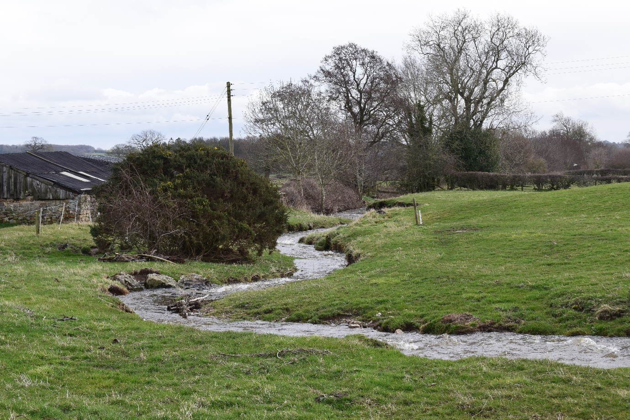
Figure 1. Swinney Beck upstream of Low Spelder Banks
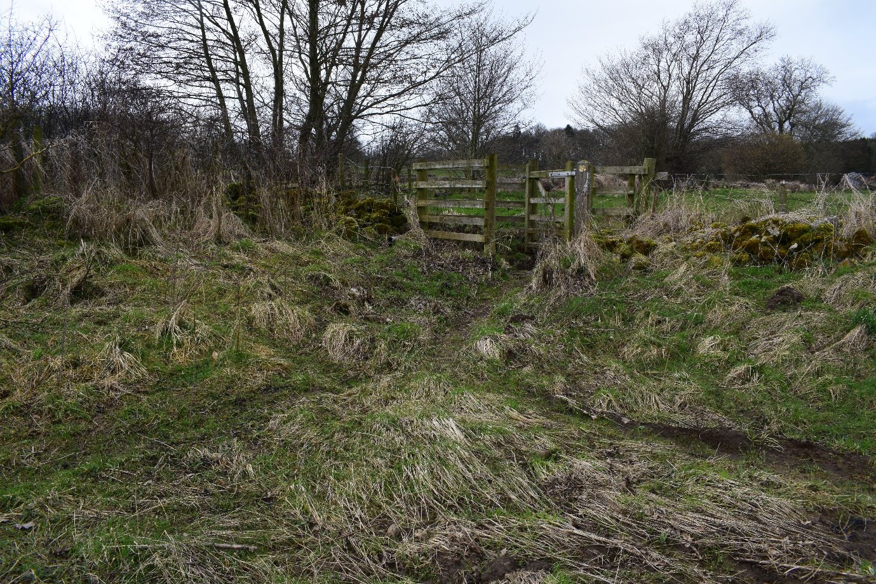
2 Evidence of out of bank flow downstream of Low Spelder Banks
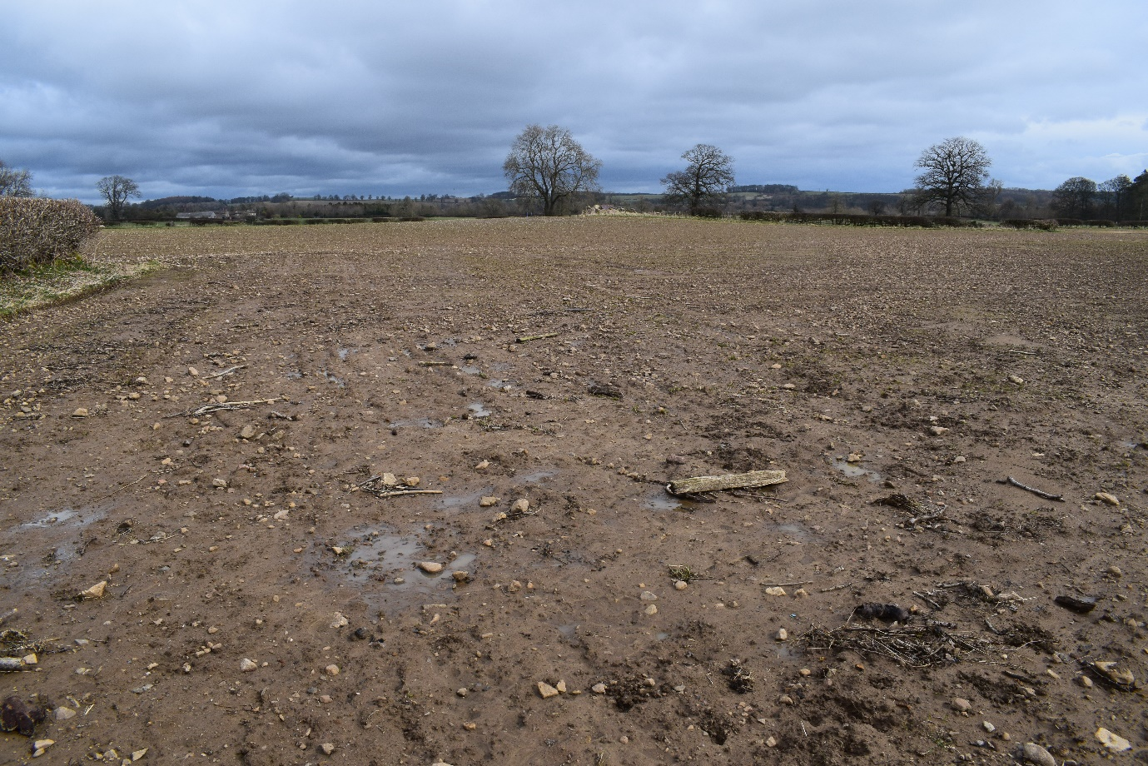
3 Looking towards Stoney Bottoms Plantation. Evidence of river debris on fields
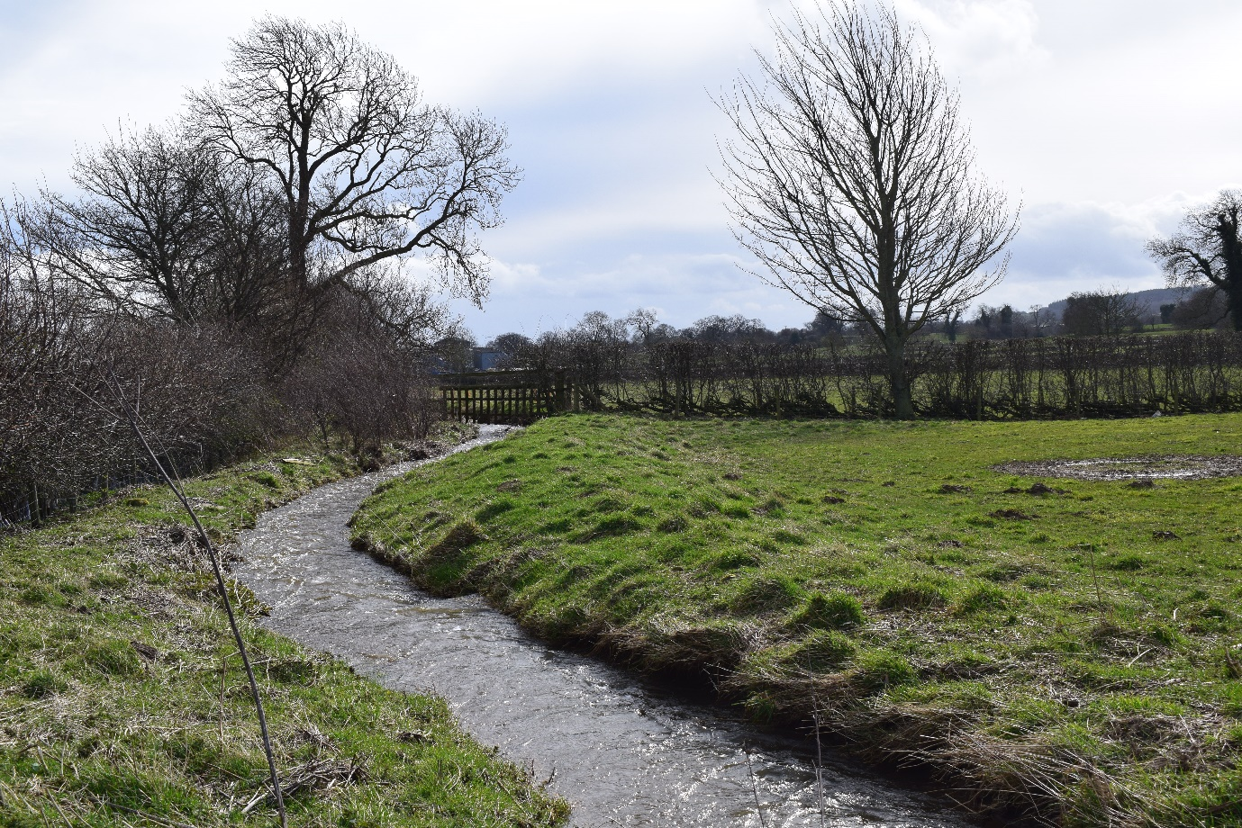
4 Evidence of raised banks on western (Fearby) side.
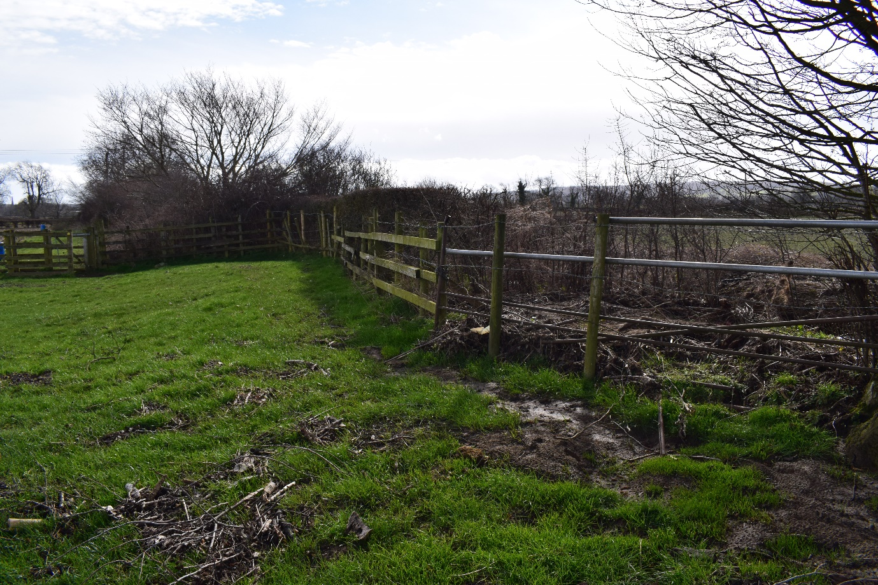
5 Debris on fields caused by overflow of beck
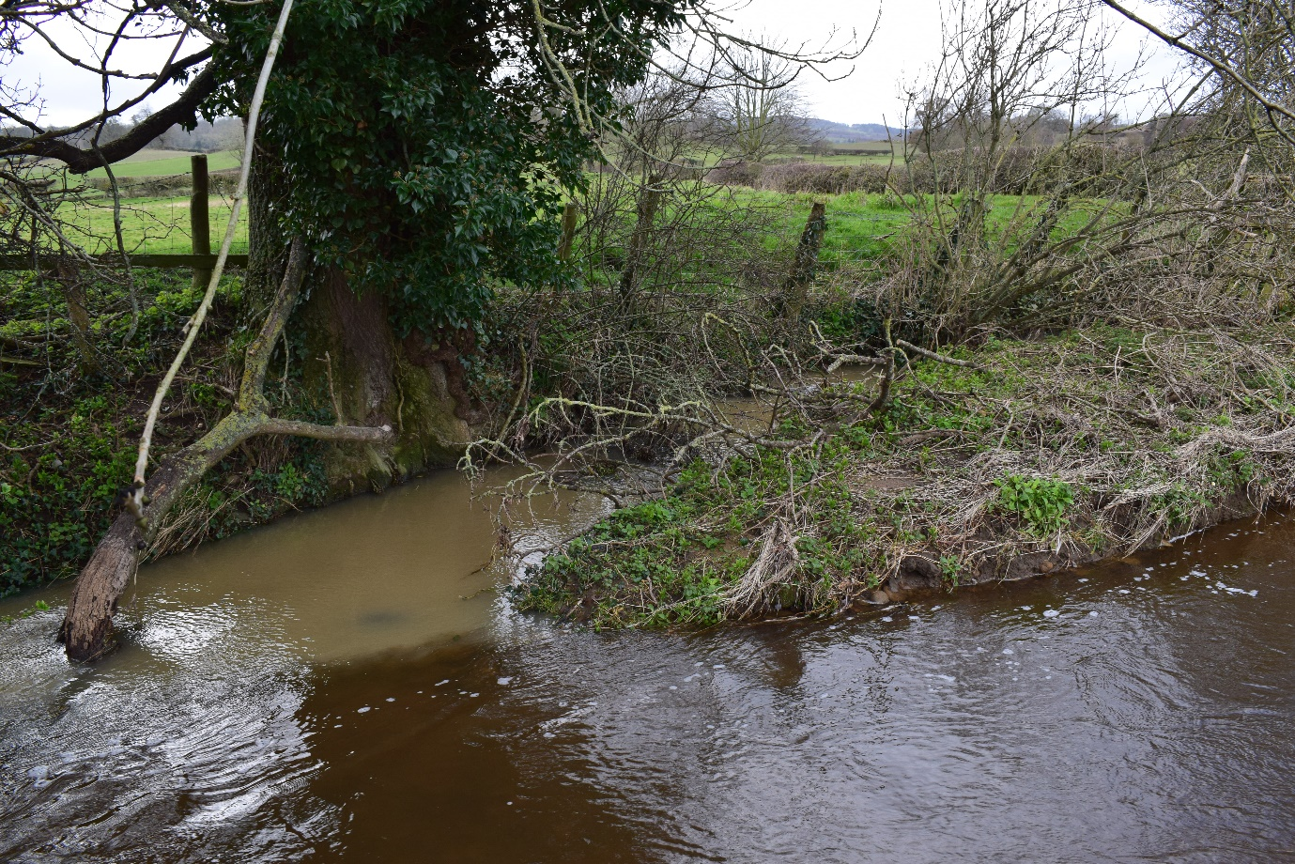
6 Confluence of Swinney Beck and Alder Beck
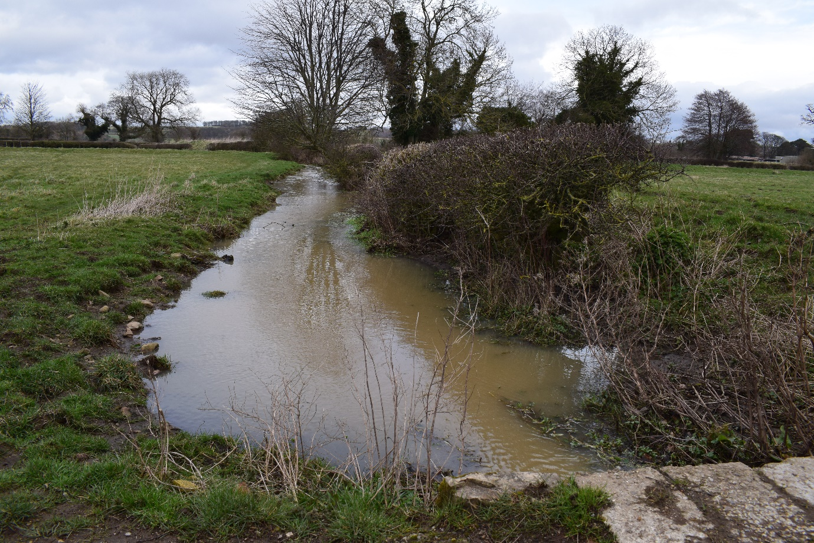
7 Alder Beck looking toward Fearby
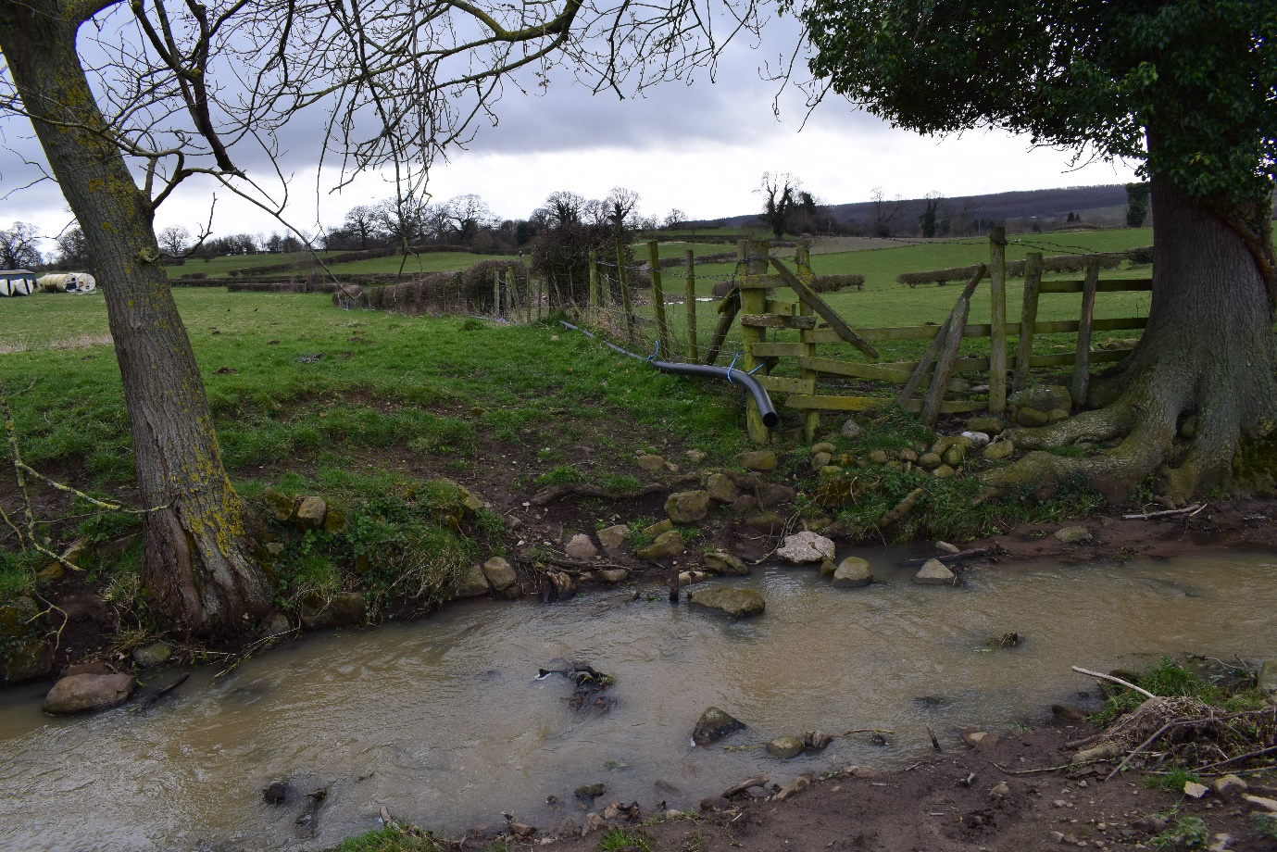
8 Water pipe flowing into Alder Beck from flooded field west of Jameson's Mil
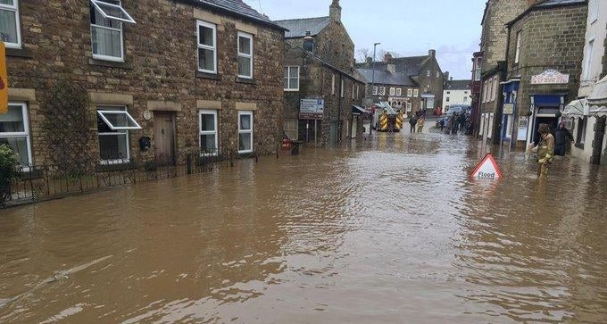
9 Flooding to Silver Street, Masham

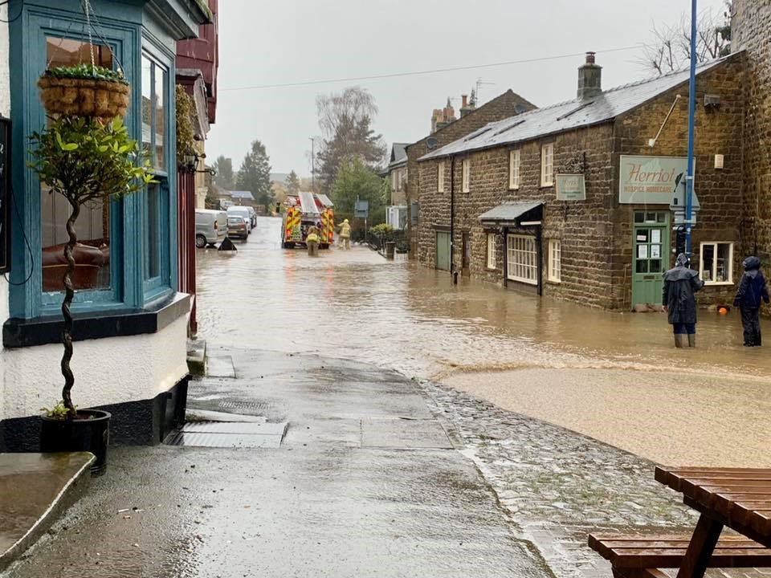
10 Flooding to Silver Street, Masham

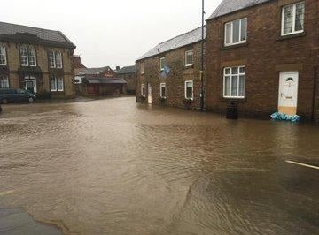
11 Flooding to Park Street, Masham

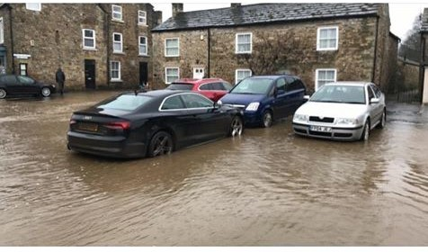
12 Flooding to Park Square, Masham
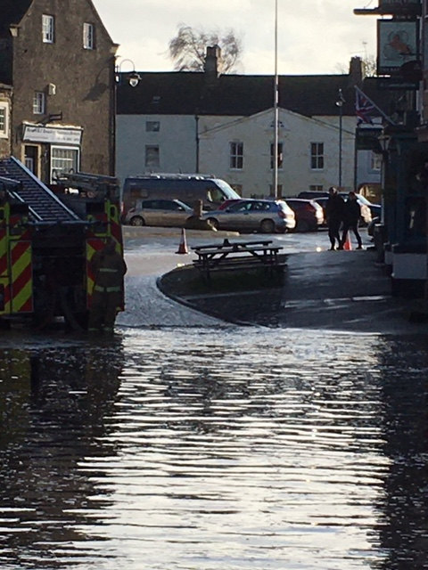
13 Flooding to Silver Street, Masham
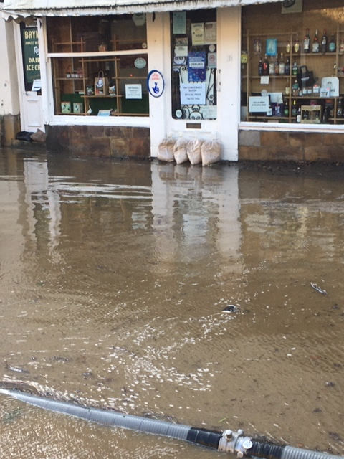
14 Flooding to Silver Street, Masham
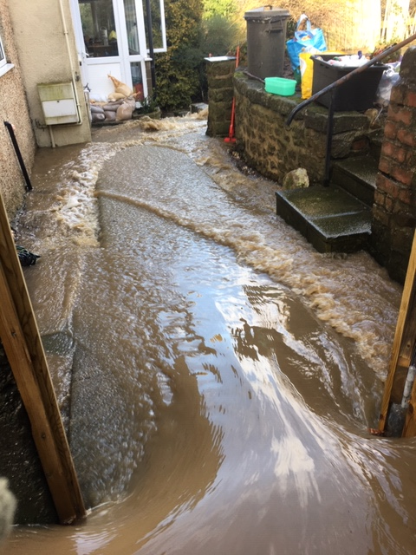
15 Flooding into garden Silver Street, Masham
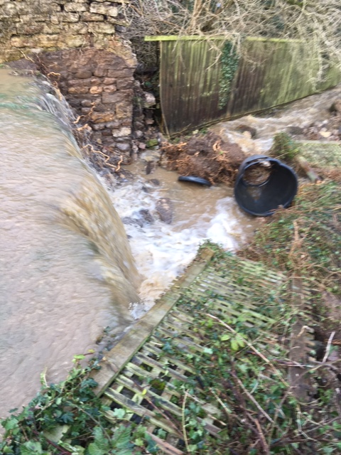
16 Flooding out of garden Silver Street, Masham towards Recreation Ground
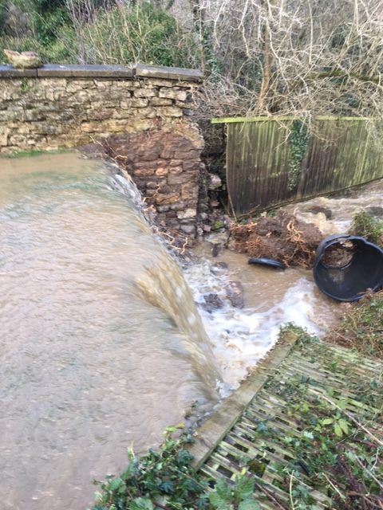
17 Flooding out of garden Silver Street, Masham towards Recreation Ground
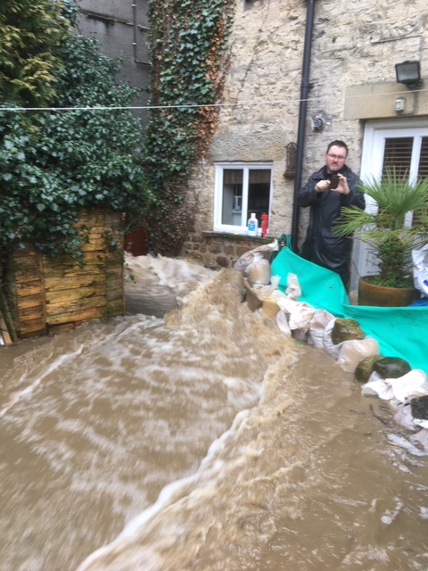
18 Flooding in rear garden at Silver Street, Masham
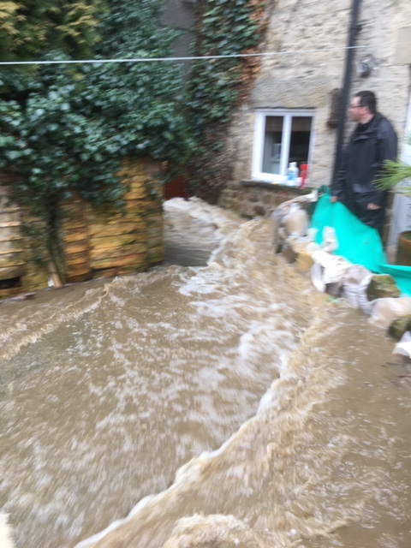
19 Flooding in rear garden at Silver Street, Masham
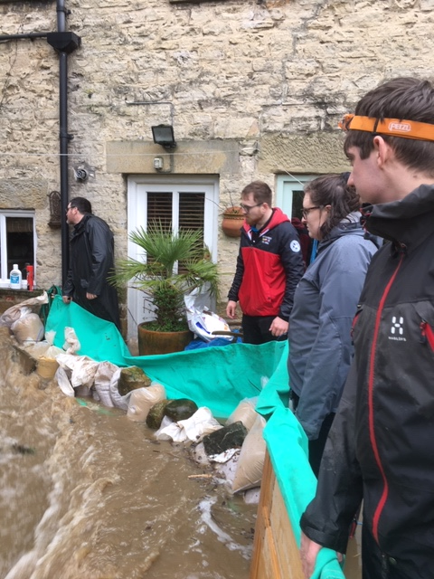
20 Flooding in rear garden at Silver Street, Masham
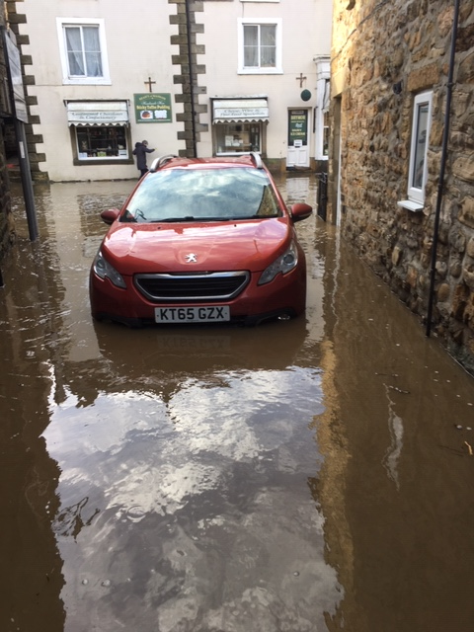
21 Flooding in driveway at Silver Street, Masham
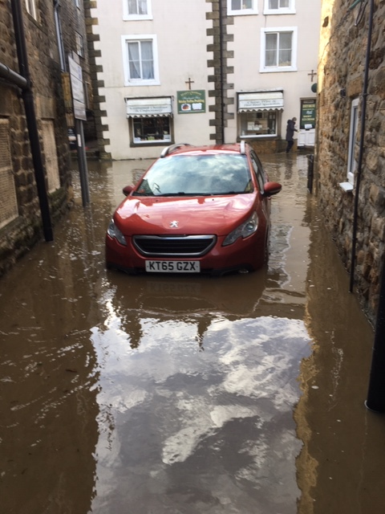
22 Flooding in driveway at Silver Street, Masham
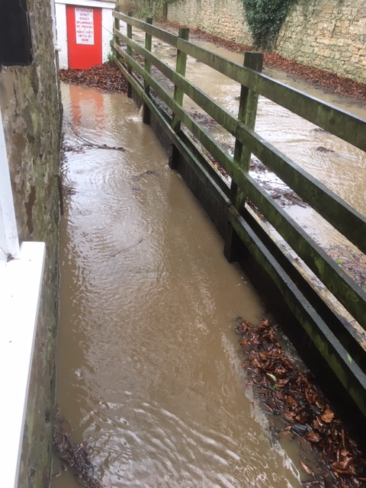
23 Flooding beside fire station and Red Lane ginnel
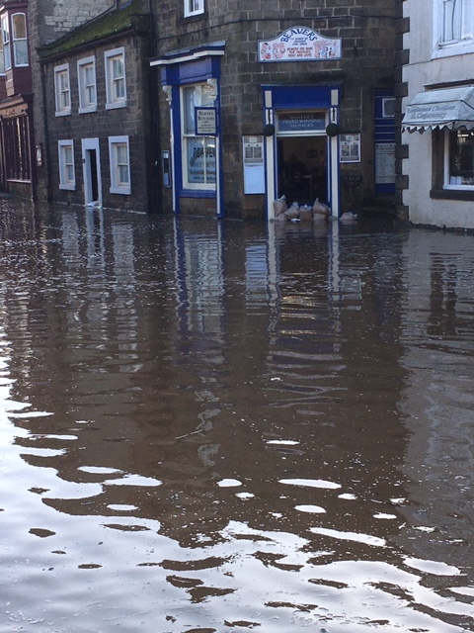
24 Flooding to Silver Street, Masham

CONCLUSION
All things considered, any action the local Council can take appears to be nothing more than a ‘sticking patch’ solution and does not resolve the original problem which is to slow the flow of water into Masham to a level where the river and drains can cope.
Options available may include:
- Provision of overspill containment higher upstream towards Low Spelderbanks
- Reverting the Swinney to its original course, via Marfield Quarry to the River Ure upstream of Masham, and without it joining the Alder Beck. Alder Beck would continue to flow through Masham to the Ure but carrying a much reduced volume of water.
Please accept this as a formal request from Masham Parish Council on behalf of its population, to explore and report back on the situation on this river, as to what schemes might be possible for flood alleviation, what funding might be available, and on any proposals which might already be in place.
Please confirm whether the EA has knowledge of a proposal to divert the Swinney back to its original course as part of future development of quarrying in the Masham Area for which it is understood that planning authority may be in place. What might be the timescale for this work, and what is the prospect of it being bought forward.
Thank you
Masham Parish Council

