WCA FORM D

PUBLIC RIGHTS OF WAY USER EVIDENCE STATEMENT

The information you provide in this statement will form part of an application that seeks to change the North Yorkshire Definitive Map and Statement (the legal record of public rights of way). Once complete you may either return the form to the person making the application or to the Definitive Map Team, North Yorkshire County Council, County Hall, Northallerton, DL7 8AH.

This statement is intended to provide preliminary evidence about the application. When North Yorkshire County Council (NYCC) commences detailed research, an officer from the County Council may contact you to seek further information or ask you to be interviewed about your evidence.

This statement is designed to help establish whether or not the route being claimed in the application is a public right of way, and/or the status of the right of way (footpath, bridleway yet). It also provides evidence of how it is used (for example on foot, on horseback, by vehicles etc).

You should answer the questions as fully as possible and not keep back any information, whether for or against the public claim. This is important if this information is to be of real value in establishing the status of the application route. The information given may be examined at a public inquiry. Changes to public rights of way have to be dealt with by a public process because they affect the public’s rights.

This statement should be completed by one person only and should relate to only one route. If you need more space please continue on a separate sheet which will need to be attached to this statement.

Please ensure this statement is completed legibly and in black ink.

Confidentiality – Please Read Carefully

The information you give in this statement cannot be treated as confidential.

- The information you provide will be retained by NYCC who is ‘the Order Making Authority’ (the OMA), for the purposes of undertaking its statutory obligations in accordance with the Wildlife and Countryside Act 1981, section 53. For the purpose of data protection, the OMA is the data controller. NYCC may use an Agent to undertake certain obligations on its behalf. If so the Agent will be the data processor.

- It may be necessary for NYCC to disclose information received regarding the application to others, which may include other local authorities, the Planning Inspectorate and other government departments, public bodies, other organisations, landowners and members of the public. This includes the information you give in this statement, as well as other evidence relating to the application. If the application proceeds to a public inquiry your evidence will be made available to the inquiry.

- If NYCC proceeds with the application but it is contested (for example by a landowner), there may be a public inquiry. This will be held locally and if you are unable to attend your evidence will be given in writing, but user evidence is of much greater value if you attend in person and are prepared to answer questions about it. Inquiries are kept as informal as possible and NYCC officers will help you with the procedure.

- The information you give in this statement will be processed in accordance with the General Data Protection Regulation. It is held by NYCC’s Public Rights of Way Team for the sole purpose of processing the application for the route referred to, and for no other purpose.

DECLARATION – Important, please read carefully

General Data Protection Regulation (GDPR)

Under the GDPR the County Council has a duty to inform you about how your personal data will be handled. Information provided in this statement will be used so that the OMA may undertake its statutory duties in accordance with the Wildlife and Countryside Act 1981 section 53. In order to determine if and how a public right of way should be recorded on the Definitive Map and Statement it may be necessary to disclose information received from you. The information provided on this statement cannot be treated as confidential (other than your personal contact details and signature contained on this page). You should only provide us with the information requested if you are happy for it to be placed in the public domain. Do not include information about another person.

This statement and the details contained therein will be retained by the OMA and considered and published as part of its statutory duty to determine the application to establish whether a public right of way exists. In signing it, you are acknowledging that it may be made publicly available and published on the County Council’s website.

Please print your name here ………………………………………………………………………….

Your: Home Telephone Number ……………………………………………………………………..
Mobile Telephone Number ……………………………………………………………………

Email Address ……………………………………………………………………………………….

Statement of Truth:

I BELIEVE THAT THE FACTS AND MATTERS CONTAINED IN THIS STATEMENT ARE TRUE AND I HAVE READ THE DECLARATION ABOVE

Your Signature:

Date:

You should keep a copy of the completed statement

Warning: If you dishonestly enter information or make a statement that you know is, or might be, untrue or misleading, and intend by doing so to make a gain for yourself or another person, or to cause loss or the risk of loss to another person, you may commit the offence of fraud under section 1 of the Fraud Act 2006, the maximum penalty for which is 10 years’ imprisonment or an unlimited fine, or both.

Information on this page of the Statement will be redacted and not made publicly available

WCA FORM D - PUBLIC RIGHT OF WAY USER EVIDENCE STATEMENT

ABOUT YOU
Name …………………………………..……………………………………………….………………..…………………………………………………..
Address …….………………………………………………………………………………….……..………………………………………………………
……………….……………………………………………………………………………………………………………………………………………………
…………………….………………………………………………………………………………………………………………………………………………
…………………………………………………..……………………………………………………………Postcode ……………………………………
Year of Birth …………………………………….……….……… Occupation …………………………………….……………..……………
Have you lived at any other addresses during the time you have used the path or way?
If so, please provide details and years [full addresses are not required]
………………………….…………………………………………………………………………………………………………………………………………
…………………………………………………………………………………………………………………………………………………………………….

ABOUT THE APPLICATION ROUTE
Describe the application route (include start and finish points and provide OS grid references if you can)
……..………………………………………………………………………………………………………………………………………………………….
………………………………………………………………………………………………………………………………………………………………...
…………………………………………….….……………………………………………………………………………………………………………….
………………………………………………………………………………………………………………………………………………………………...

MAP OF THE APPLICATION ROUTE
Please use the map on the next page to identify the route you are providing evidence about, and annotate it with anything you provide details about in this statement (eg different routes used, locations of gates, stiles, signs etc).

On the map, draw a line along the exact route you used and then, using the same colour & line-style, draw your line in the map key at the bottom of the map, alongside “Route I used”.

Please sign your name and date your map in the Declaration at the bottom of the map.
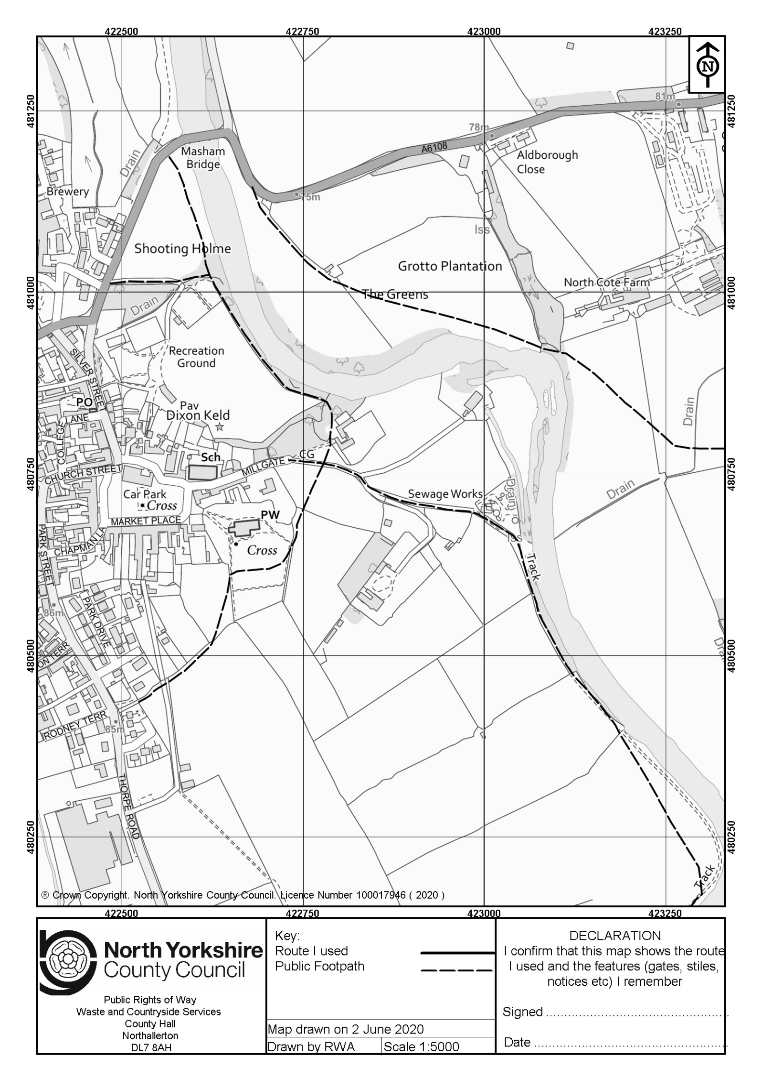
YOUR USE OF THE APPLICATION ROUTE
- In which years did you use the application route? (eg from 1974 to 2005)
From …………………………………….……. To …………………………………………

- Were there any extended periods during which you did not use the route at all? If so, please state when and why?
…………………………………………………………………………………………………………………………………………
……………………………………………………………………………………………………………………………………………

- How did you use the application route and how often? [Please tick any that apply and include dates]

 | Daily | Weekly | Monthly | Every few months | Once a  year | Other  (please describe)
Example  On Foot | Yes (or √)  1975-1990 |  |  | Yes (or √)  2010-2016
On foot

On horseback

By pedal cycle

By car

Other [please specify]
…………………………..

- Has the route you used always followed the same course?
Yes No

If no – how and when was the route altered? …………………………………………………………………………………...
………………………………………………….……………………………………………………………………………………………………….

- For what purpose did you use the route? ………………………………………………………………………………………..…
…………………………………………………………………………………………………………………………………………………………….

- Approximately how wide is the application route? ………………………………………………………………………………
[Please give your estimate of the width across which you used the route including the width used when passing others or walking with others. Take care to consider the overall width of the route. If this varies, please describe how] [Or please state ‘Don’t know’]
- What type of surface does the application route have? (for example grass, gravel, earth)
[For varying surfaces, please describe with reference to your map]
……………………………………………………………………………………………………………………………………..………………………………
……………………………………………………………………………………………………………………………………..………………………………

- Have there ever been any of the following on the application route?
- Stiles Yes No Don’t know / can’t remember

If yes, how long were they in place? Please state locations of any stiles and show on your map
………………………………………………………………………………………………………………………………………………………………………
………………………………………………………………………………………………………………………………………………………………………

- Gates Yes No Don’t know / can’t remember

If yes, state locations, indicate whether locked – and when - and show on your map
………………………………………………………………………………………………………………………………………………………………………
………………………………………………………………………………………………………………………………………………………………………

- Other barriers Yes No Don’t know / can’t remember

If yes, state what they were and location, how long they were in place and show on your map
……………………………………………………………………………….……………………………………………………………………………….…….
……………………………………………………………………………………………………………………………………..……………………………….
…………………………………………………………………………………………………………………………………………..………………………….

- Did any of the above prevent you from using the application route?
Yes No

If yes, please give details
……………………………………………………………………………………………………………………….……………………………………………..
……………………………………………………………………………………………………………….……………………………………………………..

- Have you ever seen any signs or notices suggesting whether or not the application route is a public right of way? (for example “Footpath”, “Private”, “Keep Out”, “No Right of Way”, “Trespassers will be Prosecuted” etc)

Yes No Don’t know / can’t remember

If yes – give details, including what they said, when they were present and mark their location on your map
………………………………………………………………………………………………………………………………………………………………………
………………………………………………………………………………………………………………………………………………………………………
- Have you seen other people using the application route?
Yes No
If yes, please provide any additional information about this (eg when & how often you saw them, whether
they were on foot, bicycle, horse, motorbike etc)
…………………………………………………….………………………………………………………………………………………………………...……
………………………………………………………………………………………………………….…………………………………………………...……

LAND OWNERSHIP
- Do you know the current or any previous landowners or occupiers of the land crossed by the
application route? If yes, please give details (names and dates of ownership / tenancy etc)
…………………………………………………………………………………………………………………………………………………….………….
………………………………………………………………………………………………………………………………………………………………..

- Were you working for any owner or occupier of land crossed by the application route at the time when you used it, or were you then a tenant / licensee of any such owner?

Yes No
If yes, provide details and dates
……...……………………………………………………………………………………………………...........................................................
……………………………………………………………………………………………………………………………………………………………………..

- Did the owner or occupier ever give you permission (or did you seek permission) to use the route?
Yes No

If yes, by whom and when? …………………………………………………………………………………………………………………………
.…………………………………………………………………..………………………………………………………………..………………………………

- Has anyone ever told you the application route was not public (including by an owner, tenant of the land or by anyone in their employment)?

Yes No

If yes, by whom and when? …………………………………………………………………………………………………………………………
…………………………………………………………………………………………………………………………………………………………….………

- Have you ever been stopped or turned back when using the application route?
Yes No

If yes, please give details including when this happened
……………………………………………………………………………………………………………………………………………………………………
……………………………………………………………………………………………………………………………………………………………………
- Has anyone else ever told you that they were prevented from using the application route?
Yes No
If yes, please give details including when this happened
…………………………………………………………………..………………………………………………………..………………………………………
……………………………………………………………………………………………………………..………………………………………………………

- Have you ever had a private right to use the application route? (eg, an easement or private right
of access to property you owned or rented, other private right of access, licence, etc)
Yes No
If yes, please give full details, including type of right, who gave the permission, why and when
............................................................................................................................................................................
............................................................................................................................................................................

OTHER INFORMATION
- Do you have, or do you have knowledge of, any documentary evidence which is relevant to the application route or which indicates public use? (for example photographs, guidebooks, letters, sale
documents, old maps, etc)
Yes No
If yes – please give details and provide copies if possible
…………………………………………………………….………………………………………………………………………………………………………
…………………………………………………………………..…………………………………………………………………………………………………

- Please give any further information which you consider would be helpful in reaching a decision as to whether the application route should be recorded as a public right of way?
[Continue on a separate sheet if necessary. If you wish to provide a separate sketch map, please do so
and attach to this statement]
………………………………………………………………………………………………………………………..…………………………………………..
………………………………………………………………………………………………………….……………..…………………………………………..
…………………………………………………………………………………………….…………………………..…………………………………………..
……………………………………………………………………………………………………………………………………………………………………..
……………………………………………………………………………………………………………………………………………………………………..
………………………………………………………………………………………………………….……………..…………………………………………..

- During the investigation the County Council may want to interview some or all of the witnesses in order to gather additional information. Would you be willing to talk to an officer from the County Council
about your knowledge of the application route?
Yes No

- Would you be willing to attend a hearing, or public inquiry to give evidence if necessary?
Yes No

